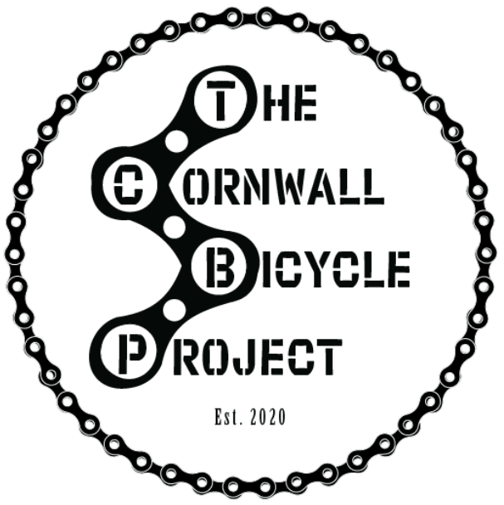

GROUP REFERRAL FORM STRICTLY CONFIDENTIAL

Office use: Date and Initial
Date Received:
Date Allocated:
Date Invoiced:
DatePaid:
Date work commenced:

Please return this form to: E2 Formal Business Park Camborne TR14 0PY
e-mail: education@cornwall-life-recycle.co.uk Telephone: 01209 697170

Group Details

Group Name | Group size | Age range
Address |  | School Attended (if appropriate)
Name of Group lead |  | Contact number and email
Emergency contact

(please note, we need a minimum of 2 contacts on this form)

Referrer Details

Name | Agency
Address | Contact Number
Email

Details of Referral

Reason/purpose for Referral

Please comment on each of the following for the group clearly identifying any risks or vulnerabilities. If no history of this issue please write ‘NH’. This will enable us to match the needs of the group.

Physical health

Mental health

Safety in the community/out and about
Substance misuse

Physical violence

Verbal abuse

Sexualised behaviour

Absconding
(eg. taking flight)

Offending

Social media/ gaming

Extreme views

Harm to self

Interaction with others (peers/family /authority)
Support accompanying group

Please forward your existing Risk Assessment if appropriate and any further details that may be relevant.

Any further information that may effect the delivery to the group

Funding agreed by:

Name: Signature:

Organisation:

Date: e-mail address:

